**Project Design Phase-II**

**Technology Stack (Architecture & Stack)**

| Date | 1 July 2025 |
| --- | --- |
| Team ID | LTVIP2025TMID49753 |
| Project Name | Heritage Treasures: An In-Depth Analysis of UNESCO World Heritage Sites |
| Maximum Marks | 4 Marks |

**Technical Architecture:**

The Deliverable shall include the architectural diagram as below and the information as per the table1 & table 2

**Example: Web Dashboard for exploring heritage data( online plays offline access).**

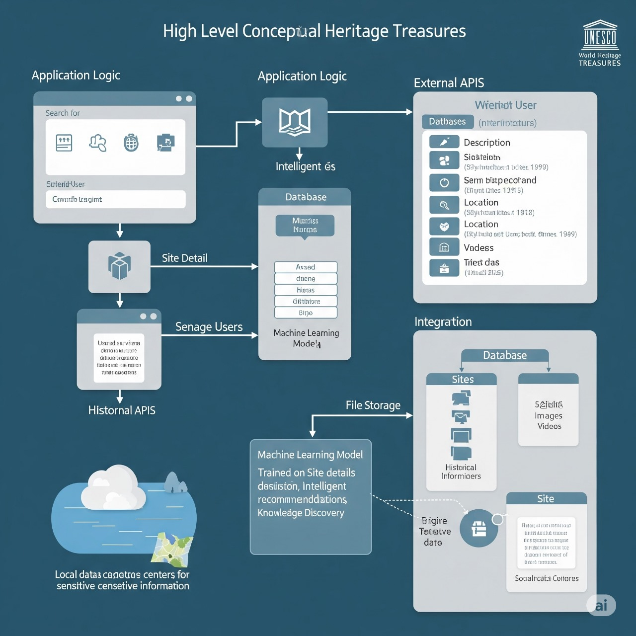

**Table-1 : Components & Technologies:**

| **S.No** | **Component** | **Description** | **Technology** |
| --- | --- | --- | --- |
|  | User Interface | Web interface to visualize.UNESCO Data Maps. Charts. | HTML, CSS, JavaScript, Tableau Embedded. |
|  | Application Logic-1 | Data filtering and category logic. | JavaScript , Python. |
|  | Application Logic-2 | Time presentation using interactive dashboard. | Tableau story. |
|  | Application Logic-3 | Location based logic for map display. | Leaflet.js, or Google Maps API. |
|  | Database | Data set storage.UNESCO site details. | MySQL/Google Sheets/CSV. |
|  | Cloud Database | Optional cloud storage. | Firebase/Google Cloud SQL. |
|  | File Storage | Dashboard image/ assets storage | Google Drive/ firebase storage. |
|  | External API-1 | Geolocation or map integration | Google Maps API. |
|  | External API-2 | Whether data or country metadata. | Open Weather API/REST countries API. |
|  | Machine Learning Model | (Optional)Predict threat level or clustering heritage sites. | Scikit-learn/TensorFlow(if used) |
|  | Infrastructure (Server / Cloud) | Hosted on local or cloud. | Google Cloud /localhost. |

**Table-2: Application Characteristics:**

| **S.No** | **Characteristics** | **Description** | **Technology** |
| --- | --- | --- | --- |
|  | Open-Source Frameworks | HTML, JavaScript, Python, Tableau Public(free) | Open source. |
|  | Security Implementations | Embedded production controlled access to dashboard. | SSL/HTTPS, O Auth(if used) |
|  | Scalable Architecture | Tableau dashboards support up to large data sets. | Tableau Server/cloud hosting. |
|  | Availability | Dashboard available online, hosted 24/7. | GitHub pages /tableau public. |
|  | Performance | Optimized loading map interactivity catching if needed. | CDN,efficient queries. |

**References:**

[**https://developer.ibm.com/patterns/ai-powered-backend-system-for-order-processing-during-pandemics**](https://developer.ibm.com/patterns/ai-powered-backend-system-for-order-processing-during-pandemics)

[**https://public.tableau.com/**](https://public.tableau.com/)

[**https://leafletjs.com/**](https://leafletjs.com/)

[**https://developers.google.com/maps**](https://developers.google.com/maps)

[**https://firebase.google.com/**](https://firebase.google.com/)